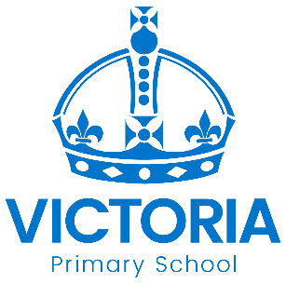

Year 6 Bridgetower, Cuffay and Naoroji Classes Newsletter: 31st August 2020

Dear Parents/Carers,

Welcome back from all the staff in Year 6. We are all looking forward to the start of the term and getting to know the children over the next few weeks. Year 6 is a little different this year as we have three classes. You will be familiar with Bridgetower, but now we have Cuffay and Naoroji class. Mr Pickering who has moved from Year 4 will be in Bridgetower class. Mr Longdon will be teaching in Cuffay class and Miss Moore will be teaching in Naoroji class. Miss Woodhouse will return as our brilliant Teaching Assistant across Year 6.

Nottingham Past and Present
Our first topic will take the children back in time as they learn about the history of Nottingham. They will study how the city grew from Anglo-Saxon times, when it was called Snotengaham, to modern day. Through a visit to the Nottingham Caves they will learn how people have used the caves to live and work in over centuries and even shelter in during World War 2.

PSHE
As we return this year, our PSHE will help us to support pupils with the transition back into school, help them understand their emotions and re-introduce them to social and behavioural expectations at school. If you have any concerns or questions about your child returning to school please speak to one of us, we are here to help and support. We will also be exploring learning about the laws surrounding equality in the UK and British Values, including liberty and tolerance.

Homework
This year the children will be given CGP homework books which the children are responsible for. They will be given 10-minute tests to answer at home each week and need to record the time they completed the test in and their score. Children are also expected to read at least three times at home and this should be recorded in their reading diaries. There will also be weekly spelling tests on a Monday.

Home-School Diaries should be brought into school every day.

Uniform
Year 6 is the last year in primary school and therefore we expect children to be independent and responsible for their uniform and belongings. All pupils are expected to wear school uniform including black shoes. For a detailed list of the uniform please look on the website under information. For PE, children are expected to wear royal blue shorts and a white tee shirt. In winter it is a good idea to bring some warm joggers in case we are outside. Sensible trainers without black soles are also needed. Please can children bring in their PE kits from Monday to Friday and take it home to wash at the weekend as the timetable can sometimes alter.

