Year 6 Bowden & Fothergill Classes
Newsletter: 25th February 2019
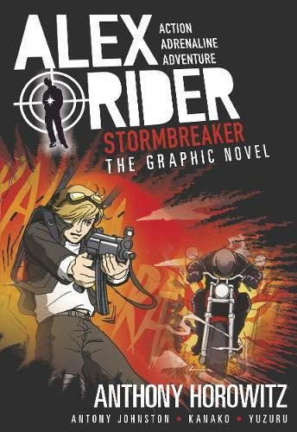
This half term, Year 5 will be attending Spy School. We will be learning a range of skills such as reading maps and acquiring a plethora of knowledge from famous spies such as Alex Rider to enable us to become Secret Spies. It is crucial that all pupils have their PE kits in school throughout the term so that they can access basic training. Homework is with this letter- please follow the instructions for homework carefully.
This letter will self-destruct after reading.

School Uniform
Please ensure all uniform is labelled with your name. It is also helpful for lunch boxes, bags and PE kit to be labelled.

Homework
Homework will be sent home in the first week and will support the children’s learning of vocabulary, grammar, number and topic. As always, reading remains a key priority to support learning and children are expected to read regularly at home. Please continue to practise times tables weekly.

Diary Dates: Spring 2019

Date | Year Group | Time | Event
Thursday 7th March | All | Day | World Book Day
Thursday 7th March | Year 3 | Day | Year 3 Mega Sports Festival  at Harvey Haddon Stadium
Thursday 14th March | Year 5 | Day | Year 5 Mega Sports Festival  at Harvey Haddon Stadium
Friday 15th March | All | Day | Red Nose Day
Tuesday 26th March | Year 5 & Cadbury | Day | Space Centre Trip
Thursday 28th March | Year 4 | Day | Year 4 Mega Sports Festival  at Harvey Haddon Stadium
Thursday 28th March | Year 3 & 5 | PM | Language Event: Arabic Afternoon
Thursday 28th March | Nursery, Reception Year 1 & 2 | PM | Mother’s Day Afternoon Tea Family Event
Friday 29th March | Years 3 - 6 | PM | Mother’s Day Afternoon Tea Family Event
Wednesday 3rd &  Thursday 4th April | All | PM | Parent – Teacher Meetings
Friday 5th April | All | Day | Super Sock Day  Wear your craziest sock combinations to mark Autism Awareness Week
Friday 5th April | All | 3.15pm | School Closes for Easter Holiday

