Year 5 Bowden and Fothergill Classes
Newsletter: 7th January 2019

Happy New Year! We hope you have had a good break and are ready to work hard. We have lots to be looking forward to this term!

Our history topic is Aztecs which we will link to our English learning. In English we will also be learning about the famous poet Benjamin Zephaniah and in science we will be exploring the exciting topic of Earth and Space! We will be looking at art and architecture in RE as well as how charities express spiritual ideas. We will investigate the principles of a healthy and varied diet and develop our programming skills in Computing.

School Uniform
Please ensure all uniform is labelled with your name. It is also helpful for lunch boxes, bags and PE kit to be labelled.

Homework
Homework will be sent home on a weekly basis and will support the children’s learning of vocabulary, grammar, number and topic. Your teacher will arrange with the class the suitable day for homework to be handed in. As always, reading remains a key priority to support learning and children are expected to read regularly at home. Please continue to practise times tables.

NEW FOR THE SPRING TERM - Commando Jo (Monday afternoon)
Please make sure you bring your PE kit at the beginning of term. Due to the cold weather we strongly recommend jogging bottoms and a sweatshirt.

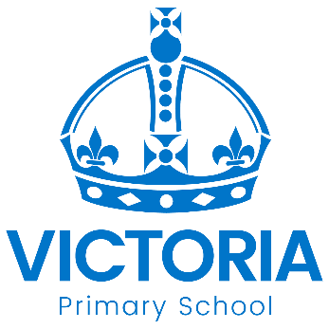

Diary Dates: Spring 2019

Date | Year Group | Time | Event
Tuesday 22nd January | Y3, 4, 5 & 6 | PM | Road Safety Quiz
Tuesday 5th February | All | Day | National Safer Internet Day learning
Thursday 14th February | Y1, 4 &6 | 1.30pm | Language Event: Polish Afternoon
Thursday 14th February | All | 3.15pm | School Closes for February Half Term
Monday 25th February | All | 8.45am | School reopens

