Year 5 Bowden and Fothergill classes
Newsletter: 5th November 2018

Welcome back! We hope you have had a good break and are ready to work hard. We have lots to be looking forward to this term!

Our main topic is the Vikings and we will be making lots of links to other areas of our learning.

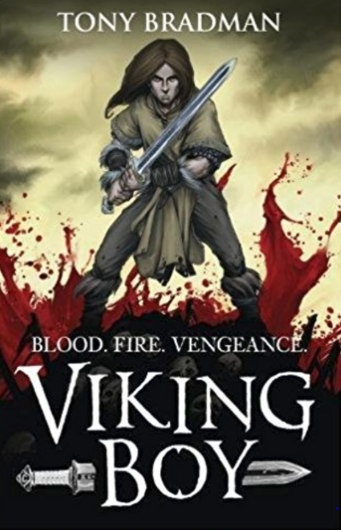
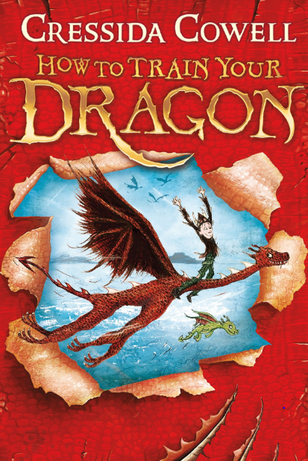
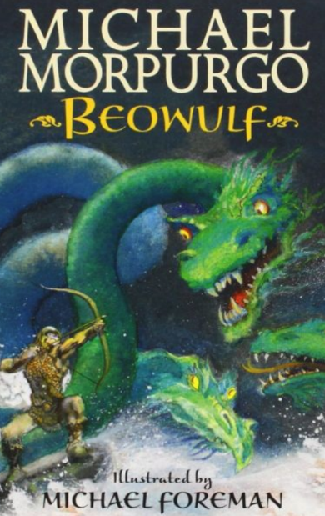

School Uniform
Please ensure all uniform is labelled with your name. It is helpful for lunch boxes, bags and PE kit to be labelled too.

Homework
Homework will be sent home on a weekly basis and will support the children’s learning of vocabulary, grammar, number and topic. Your teacher will arrange with the class the suitable day for homework to be handed in. As always, reading remains a key priority to support learning and children are expected to read regularly at home.

PE – Thursday
Please make sure you bring your PE kit at the beginning of term. We will send it home to be washed at the end of term. Plimsols/trainers, shorts and t-shirts are fine but children will need to bring a sweatshirt to school as the weather gets colder.

Diary Dates: Autumn 2 2018

Date | Year Group | Time | Event
Thursday 8th November | Year 6 | pm | WW1 Centenary Football Match Event
Friday 9th November | All | Day | WW1 Centenary Activities
Monday 12th November | All | Week | National Anti-bullying Week
Tuesday 13th November | R – Y5 | Morning | NHS Flu Vaccinations  Nose Spray not injection
Thursday 15th November | Year 2 | 9.00 – 10.00 am | Phonics for Parents workshop & watch
Friday 17th November | All | Day | Children in Need Charity Event
Tuesday 20th November | All | 2.00 – 3.30 pm | Parent and Family Support Event
Wednesday 21st November | All | 2.00 – 4.30 pm | Parent – Teacher Meetings
Thursday 22nd November | All | 3.30 – 6.00 pm | Parent – Teacher Meetings
Tuesday 4th December | Year 2 | AM | English Trip to Pantomime  at Nottingham Playhouse
Wednesday 5th December | Year 3 - 6 | 2.30 – 4.30 pm | Choir singing at Christmas Lights  Switch – on at Bridgeway Centre
Friday 7th December | R – Y6 | pm | Christingle Experience at  St George’s Church
Tuesday 11th December | Nursery & Reception | tbc | Christmas Show for families
Tuesday 18th December | Year 1 & 2 | tbc | Christmas Show for families
Wednesday 19th December | All | 3.15pm | School Closes for Christmas Holiday

