Vocabulary
Appliances | a device or machine in your home that you use to do a job such as cleaning or cooking
Battery | small devices that provide power for electrical items such as torches
Bulb | the glass part of an electrical lamp, which gives out light when electricity passes through it
Buzzer | an electrical device that is used to make a buzzing sound
Cell | a synonym for battery.
Circuit | a complete route which an electrical current can flow around
Component | the parts that something is made of
Conductor | a substance that heat or electricity can pass through or along
Current | a flow of electricity through a wire or circuit
Device | an object that has been invented for a particular purpose
Electricity | a form of energy that can be carried by wire and is used for heating and lighting, and to provide power for devices
Energy | the power from sources such as electricity that makes machines work or provide heat
Fuel | a substance such as coal, oil, or petrol that is burned to provide heat or power
Generate | cause it to begin and develop
Insulator | a non-conductor of electricity or heat
Mains | where the supply of water, electricity or has enters the building
Motor | a device that uses electricity or fuel to produce movement
Power | power is energy, especially electricity that is obtained in large quantities from a fuel source and used to operate lights, heating and machinery.
Source | where something comes from
Switch | a small control for an electrical device which you use to turn a device on or off
Wires | a long thin piece of metal that is used to fasten things or to carry electrical current
Victoria Primary School- Science
Electricity | Year 4

What will I know by the end of the unit?
Where does electricity come from? | - Electricity is generated using energy from natural sources such as the sun, oil, water and wind.  - These can also be called fuel sources.
Which appliances run on electricity? | - Some appliances use batteries and some use mains electricity.  - Batteries come in different sizes depending on how much and for how long the appliance is used.  - Common appliances that use electricity:  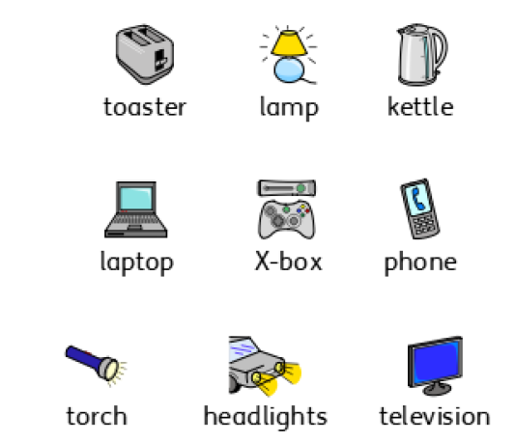
How does a circuit work? | - A complete circuit is a loop that allows electrical current to flow through the wires.  - A circuit contains a battery (cell), wires and an appliance that requires electricity to work (such as a bulb, motor or buzzer).  - The electrical current flows through the wires from the battery (cell) to the bulb, motor or buzzer.  - A switch can break or reconnect a circuit.  - A switch controls the flow of the electrical current around the circuit. When the switch is off, the current cannot flow. This is not the same as an incomplete circuit.
What are electrical conductors and insulators? | - When objects are places in the circuits, they may or may not allow electricity to pass through.  - Objects that are made from materials that allow electricity to pass through to complete a complete circuit are called electrical conductors.  - Objects that are made from materials that do not allowed electricity to pass through and do not allow electricity to pass through and do not complete a circuit are called electrical insulators.

Diagrams
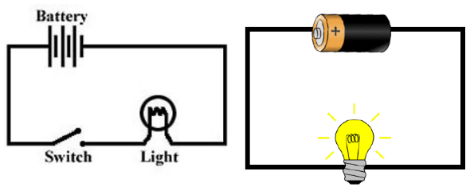
These are complete circuits- they have a battery (cell) and a component (bulb).
The wires are placed in the right places of the battery for the circuit to work.

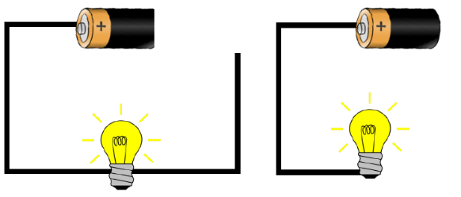
These circuits will not work as they are incomplete.

Question 7: why is it dangerous to use an electrical appliance near water?
Victoria Primary School- Science
Electricity | Year 4

1 mark
Question 1: Another name for a battery is: | Tick
Circuit
light
Buzzer
Cell

1 mark

Question 8: A circuit will not work if….. (tick three): | Tick
there is no battery
the switch is off
there is a break in the circuit
there is no switch

1 mark
Question 2: Which of these need electricity to work? | Tick
torch
mobile phone
games console
car

Question 2: Which of these need electricity to work?
torch
mobile phone
games console
car
Question 3: How will you know if a material conducts electricity? | Tick
Electricity will flow freely and the circuit will work
Electricity will not flow and the circuit will not work
The battery will not work

1 mark
Question 9: When more batteries are added to a complete circuit…. | Tick
the bulb does not go on
the light bulb becomes brighter
the circuit does not work
the switch goes off

1 mark
1 mark

Question 10: Why will this circuit not work?
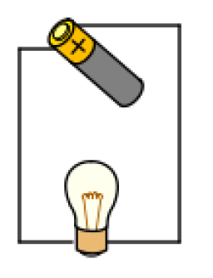

Question 4: Which of these are conductors of electricity? | Tick
plastic comb
cardboard strip
aluminium
copper coin

1 mark

Question 5: Which of these circuits will light? | Tick
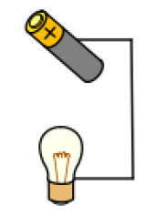
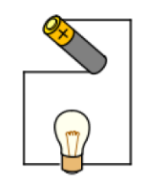

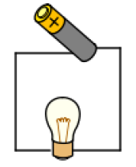

1 mark
1 mark

Score out of 10: __________________

