Learning Project WEEK 5 - Viewpoints
Age Range: Year 1
Weekly Maths Tasks (Aim to do 1 per day) | Weekly Reading Tasks (Aim to do 1 per day)
- Do the number of the day challenge  - Go on a number hunt at home. How many items can you find that have numbers on them? What is the largest number you can find? What is the smallest number you can find?  - Practise making shapes on this online geoboard. Once you have made the shape from one view, can you make it from another? How do you know it is still the same shape?  - Write the numbers 20-40 in words and digits.  - Use a scales to weigh 10 items from your kitchen. Can you order them from lightest to heaviest? | - Read a variety of books at home. Your child could share a book every day. This can be reading a book aloud or sharing a book with an adult.  - Record yourself reading and upload it to Seesaw.  - Listen to a story read, Storytime.  - Log in to “Teach Your Monster to Read” and play your next level.  - Start reading a story but stop halfway – can you make up the ending yourself? Now finish the story book and compare your ending to the real one. How are they similar/different?
Weekly Phonics/Spellings  Tasks (Aim to do 1 per day) | Weekly Writing Tasks (Aim to do 1 per day)
- Daily phonics - your child to practice their sounds and blend words. You can find lots of useful games and clips by clicking the links below.  - Phonics Play  - Help a hedgehog  - Mr. T’s Phonics  - Phonics Bloom  - Family Learning  - Do the phonics challenge of the week for your phonics group.  - Daily spelling practise  - Practise our weekly spellings.  - Spooky Spellings  - Spelling City  - Have a go at pyramid spelling. Can you use it to learn the spellings of our tricky words?  - Do one of these spelling quizzes. | - Do our weekly writing challenge  - Draw a picture of your house and label it.  - Write sentences using adjectives to describe a room in your house.  - Hide and seek: Write a set of instructions on how to find something in your bedroom. Think about the positional language to help find the object.  - Diary: Keep a diary of things that happen outside one of the windows in your house.
Learning Project - to be done throughout the week: View point
The project this week aims to provide opportunities for your child to learn more about different viewpoints. Learning may focus on physical viewpoints in terms of what you can see outside of the window at home, what others can see looking into your home and then progress onto personal viewpoints and of others.

Using your senses: Ask your child to pick a window in the house. Ask them to stand there for a few minutes and take a look at what they can see and write or draw them down. Now ask them to try this activity again but this time ask them what they can hear? Write or draw these down. Ask your child to help find a piece of material in the house and then blindfold them. What can they see? Which sense do they use now? Ask them to now cover their ears and look outside the window. What do they hear?
A ‘feely bag’ - find six objects, such as a hairbrush, a tube of toothpaste, a packet of biscuits, an ice cream scoop, a packet of tissues and a wooden spoon. You will also need something to act as a blindfold. Imagine what it would be like if you could never see because you were blind and you had to learn to rely on your other senses instead. Play with a partner and see who guesses most of the objects.
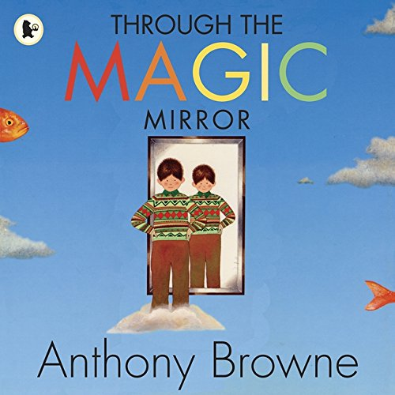
Find a mirror in the house: What can they see? Imagine if they were able to walk into the mirror. What do they think you would see? Listen to the story ‘Through the Magic Mirror’ by Anthony Browne. Look at the illustrations in the book and discuss what is different. Can they create a story similar to ‘Through the Mirror’? Draw a story map first and plan their story. Using their story map, create their story and remember to think about your illustrations.
Find a place in the house. Look around at what they can see. Sketch what they can see. What is on the left hand side of them? What is on the right hand side of them? Does it change if they sit in another part of the house? Make a list of all the things and compare.
Additional learning resources parents may wish to engage with
Classroom Secrets Learning Packs - These packs are split into different year groups and include activities linked to reading, writing, maths and practical ideas you can do around the home.
Twinkl - to access these resources click on the link and sign up using your own email address and creating your own password. Use the offer code UKTWINKLHELPS.
Headteacherchat - This is a blog that has links to various learning platforms. Lots of these are free to access.
Additional Year 1 phonics support can be found here:
https://home.oxfordowl.co.uk/reading/learn-to-read-phonics/
#TheLearningProjects

