Use this picture as the inspiration for your next great story, poem or description. Challenge yourself to use some of the exciting vocabulary we've learned to make your writing even more amazing. The words in the box might help you this week.
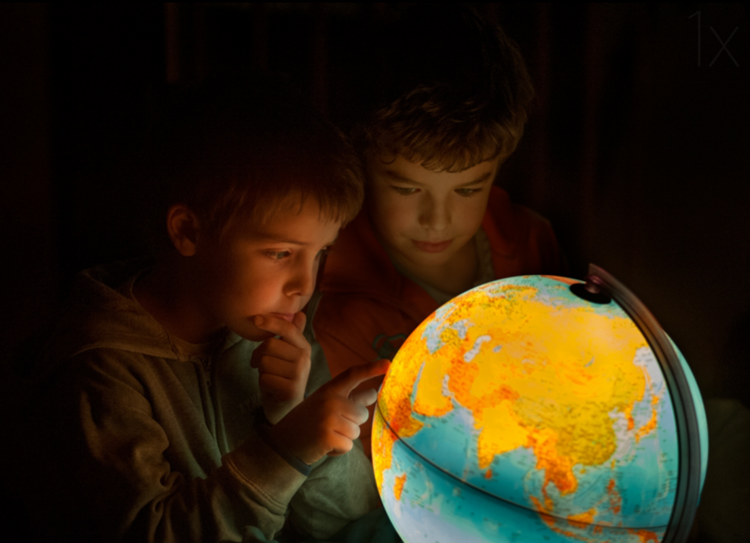
magical explore adventure decision

_______________________________________________________________

_______________________________________________________________

_______________________________________________________________

_______________________________________________________________

_______________________________________________________________

_______________________________________________________________

_______________________________________________________________

