Year 1 Learning Project –Week 12 – Food
13th - 17th July 2020
 | Monday | Tuesday | Wednesday | Thursday | Friday
Writing/Topic | Write about the picture. | Design an ice-cream flavour | Design a menu | *Special writing*  My Year in Year One | *Special writing*  My Wishes for Year Two
Phonics/spelling | Missing blends | Weekly phonics challenge | Phonics Mat | Spelling, punctuation and grammar activity mat | Common exception word mat – love
Reading | Read to an adult for 10 minutes each day / adult reads to child for 10 minutes each day
Maths | Number of the day | Activity mat | I Spy and Add to 20 | Times Tables Challenge | Final 100 square challenge

Name: ____________________________________________
Monday 13th July
Writing Challenge - Use this picture as the inspiration for your next great story, poem or description. Challenge yourself to use some of the exciting vocabulary we've learned to make your writing even more amazing. The words in the box might help you this week.
magical explore adventure decision

_______________________________________________________________

_______________________________________________________________

_______________________________________________________________

_______________________________________________________________

_______________________________________________________________

_______________________________________________________________

_______________________________________________________________
Monday 13th July
Phonics – Missing blends
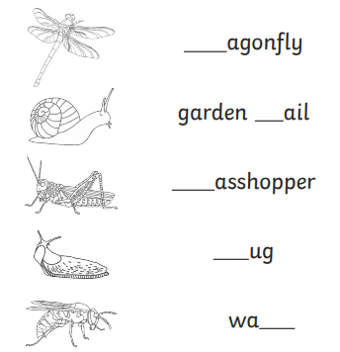
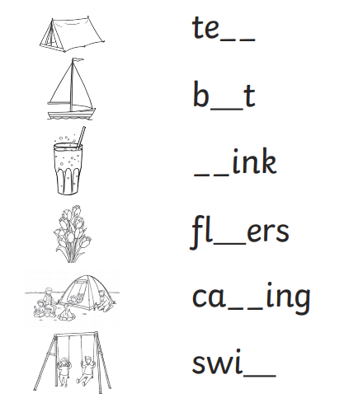
Fill in the missing blends to complete each word. The pictures will help you
Monday 13th July
Maths – Number of the Day

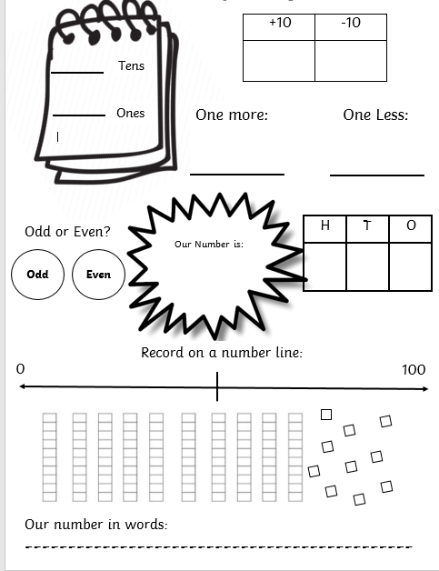
97

Tuesday 14th July
Writing – Design your own ice-cream flavour
The summer holidays are coming! Hopefully the weather will be hot enough to enjoy an ice-cream. If you could have any flavour of ice-cream, what would it be? What would you call it? Draw your ice-cream and discuss the ingredients you would choose.
Mrs. Moore says “I would choose candyfloss, rainbow drops and smarties as my flavours. Then I would sprinkle crushed-up white chocolate on top and cover it with rainbow syrup. I would call my ice-cream The Colour Explosion.”

My own ice-cream:

_____________________________________________________________________________
_____________________________________________________________________________
_____________________________________________________________________________
_____________________________________________________________________________
_____________________________________________________________________________
_____________________________________________________________________________
_____________________________________________________________________________
_____________________________________________________________________________
_____________________________________________________________________________
_____________________________________________________________________________
_____________________________________________________________________________

Tuesday 14th July
Phonics – Weekly Phonics Challenge
Choose the sound for the phonics group you are in. How many words can you come up with that have this sound in them? Can you use your favourite one to write a sentence? Can you find this sound in books and magazines at home?

4 | ir |  | ph
 | i |  | ou

_____________________________________________________________________________________________________________________________________________________________________________________________________________________________________________________________________________________________________________________________________________________________________________________________________________________________________________________________________________________________________________________________________
____________________________________________________
Today we want you to use your number skills to answer these questions. Remember if you are stuck, to use objects from around your house – Lego, stones, buttons.

Tuesday 14th July
Maths – Activity Mat
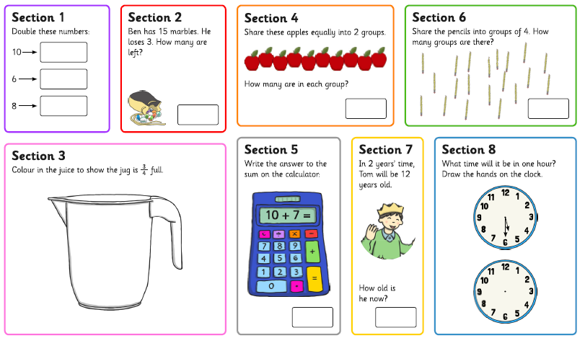

Pretend you have just bought your own restaurant. You need to design a menu. Think about which starters, main courses and desserts you will have. Will you serve special drinks like milkshakes or slushies? Will there be a menu for adults and one for kids? There is an extra page in case you need more space.

Wednesday 15th July
Writing – Design a menu

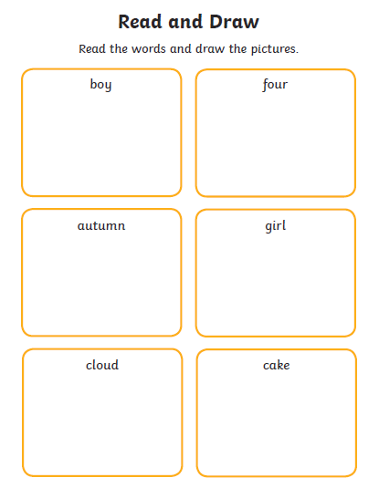
Have a go at these phonics activities. Use your blending skills.

Wednesday 15th July
Phonics – Activity Mat
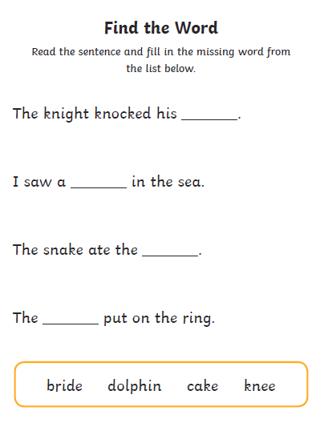
Wednesday 15th July
Maths – I spy and add to 20

Use this ‘I Spy’ sheet to answer the questions on the next page. Can you name each shape?

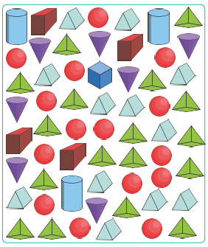

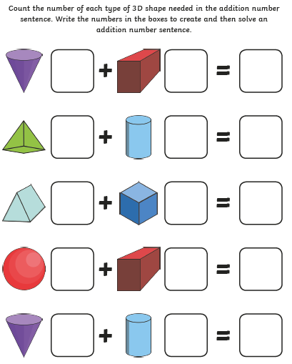

Thursday 16th July
Writing – My Year in Year 1

What an amazing year you have had! We are so proud of each of you and you should be so proud of yourselves. Write about your time in Year 1. Things to think about:
- What did you enjoy doing?
- What did you learn about or getter better at doing?
- Who did you make friends with?
- What will you miss?
- What are you proud of?

___________________________________________________________________________
___________________________________________________________________________
___________________________________________________________________________
___________________________________________________________________________
___________________________________________________________________________
___________________________________________________________________________
___________________________________________________________________________
___________________________________________________________________________
___________________________________________________________________________
___________________________________________________________________________
___________________________________________________________________________
___________________________________________________________________________
___________________________________________________________________________
___________________________________________________________________________
___________________________________________________________________________
___________________________________________________________________________
___________________________________________________________________________

Thursday 16th July
Spellings – Activity Mat
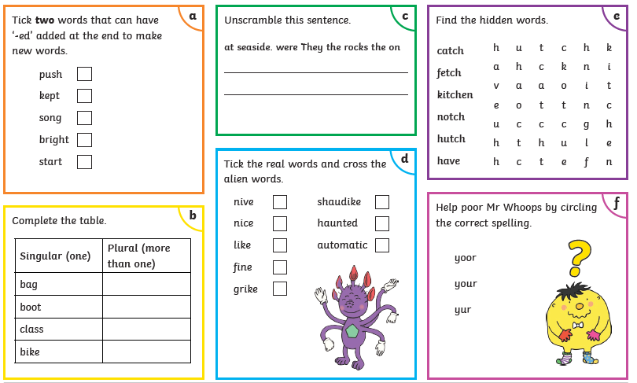

Thursday 16th July
Maths – End of year times tables challenge

Have a go at these times tables questions. See how many you can answer. You can use your knowledge of 2s, 5s and 10s to help you. Have fun
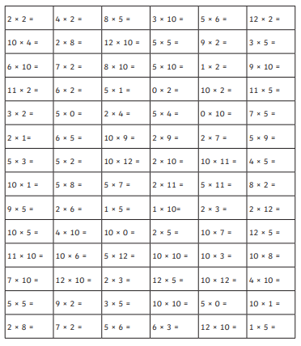
What are your wishes for Year 2? What do you hope to achieve? What would you like your new teacher to be like? What do you hope to get better at? Write your wishes on the stars. You can draw extra stars on the next page if you like.

Friday 17th July
Writing – My Wishes for Year 2

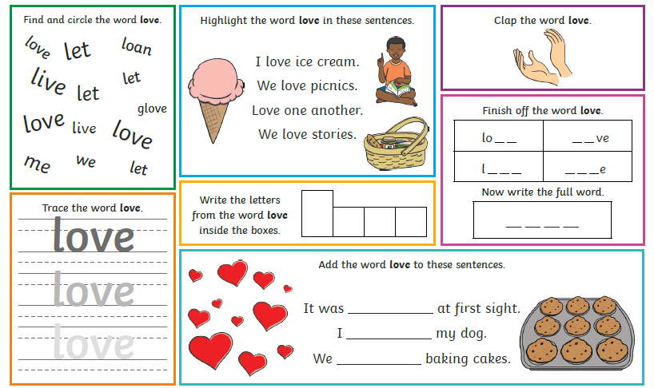
Friday 17th July
Common Exception Word Mat - love
Friday 17th July
Maths – The Final 100 square challenge!
You will need a timer – set it for 5 minutes.
You have 5 minutes to see how many numbers from 1-100 you can write on the 100 square. Remember to use your counting to help you.
Challenge – can you do it in 3 minutes? This is your last challenge – can you beat your past times?
Ch

