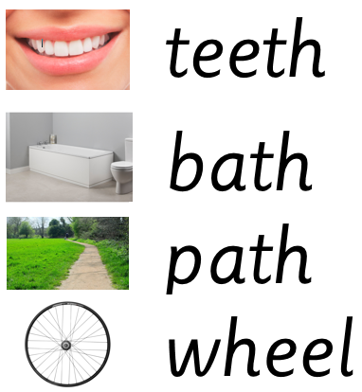

Extra words to practise: thin, thing, when, which

Extra words to practise: thin, thing, when, which