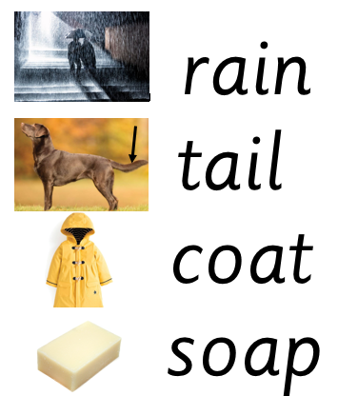

Extra words to practise: goat, boat, toad, sail, mail, nail

Extra words to practise: goat, boat, toad, sail, mail, nail