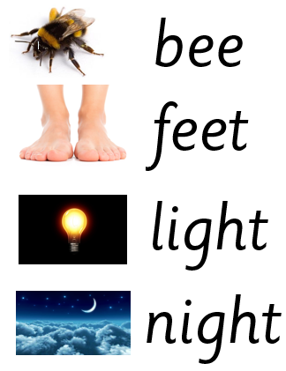

Extra words to practise: keep, meet, week, might, sight, fight

Extra words to practise: keep, meet, week, might, sight, fight