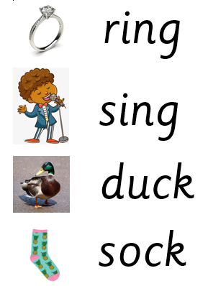

Extra words to practise: kick, back, pick, neck, wing, king, bang, long

Extra words to practise: kick, back, pick, neck, wing, king, bang, long