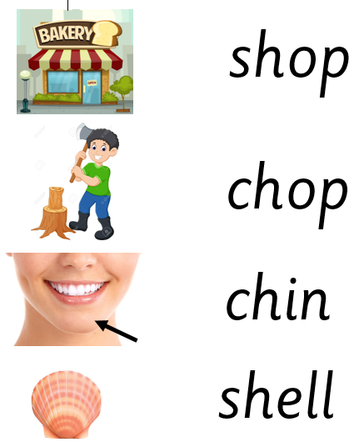

Extra words to practise: shut, ship, rush, cash, chip, much, chick, chill

Extra words to practise: shut, ship, rush, cash, chip, much, chick, chill