Reception Boot and Bell
Class Newsletter: April 16th 2018

Dear Parents

Welcome back to the Summer term!

This half- term our topic is ‘Animals’ and we will be learning about different animals and how to look after them.
We are really excited to have White Post Farm visit us for our ‘Animal Roadshow’ where they will bring in a selection of animals for us to hold and find out about. This is Wednesday 25 April. Please remember to return your £3 towards the cost.

On Tuesday 1st May we have the RSPB (Royal Society for the Protection of Birds) coming in to run a session in the Forest School. We would love for parents to join us. Simply turn up as normal in the morning and we will go over after registration.

Cooking

Look out for delicious treats and healthy eating goodies as we continue with our weekly cooking sessions.

Summer ready
As the weather hopefully improves children will need to be prepared. Please make sure they have a sun hat with them every day and are wearing sun cream (Boots do an all-day cream which you can put on in the morning)

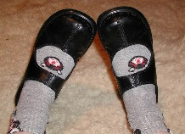
P.E
Having mastered yoga we will be trying out some other exercises. We will be playing team games every Monday so keep practicing taking your shoes and socks on and off by yourselves.

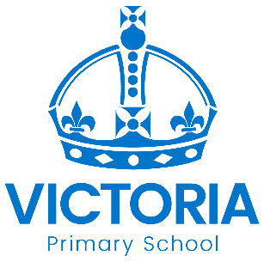

Diary Dates: March 2018

Date | Year Group | Time | Event
Thursday 1st March | Y1 – Y6 | Day | World Book Day  Non uniform – dress as a book character and come to celebrate getting into a good book.
Friday 2nd March | Reception  Y1, Y2, Y3 | AM | Free six week Parent Course  “Keeping up with the children in Maths”
Thursday 8th March | Year 3 | 9.00am | Year 3 Maths  Parents information session with Miss Cao
Thursday 8th March &  Friday 9th March | All | PM | Mothers’ Day Afternoon Tea
Monday 12th March | All | Day | STEM Day  (Science, Technology, Engineering & Maths fun for all classes)
Wednesday 14th March | Year 5 | Day | Year 5 School Council go to represent our school at Nottingham Primary Parliament
Friday 16th March | All | PM | Sports Relief Events  Active fun to finish the week!
Wednesday 21st March | Reception | AM | Walk to local shops as part of “Shopping” topic  Volunteers needed – please see a staff member
Monday 26th March | Y3 & Y5 | PM | Arabic Afternoon
Tuesday 27th March &  Wednesday 28th March | All | PM | Parent – Teacher Meetings
Friday 30th March | All | 3.15pm | School Closes for the Easter Holiday
Monday 16th April | All | 8.55am | School reopens for the Summer Term

