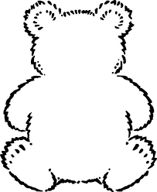

Bear 19

Bear 18

had

hat

fat

fog

fib

him

fit

his

Black font: These are phonics sounds. Your child needs to learn the pure sound, not the letter of the alphabet.

Green font: These are high frequency words that your child will regularly see in books.

Blue font: These are ‘tricky words’ which aren’t decodable.

these words

Black font: These are phonics sounds. Your child needs to learn the pure sound, not the letter of the alphabet.

Green font: These are high frequency words that your child will regularly see in books.

Blue font: These are ‘tricky words’ which aren’t decodable.

these words