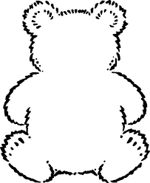

log

on

Bear 15

Bear 14

am

a

asp

hot

at

not

Black font: These are phonics sounds. Your child needs to learn the pure sound, not the letter of the alphabet.

Green font: These are high frequency words that your child will regularly see in books.

Blue font: These are ‘tricky words’ which aren’t decodable.

these words

Black font: These are phonics sounds. Your child needs to learn the pure sound, not the letter of the alphabet.

Green font: These are high frequency words that your child will regularly see in books.

Blue font: These are ‘tricky words’ which aren’t decodable.

these words