Free online courses for parents and carers
Join our Online Classes using Microsoft Teams
are easy to join

Nottingham College is pleased to be able to offer FREE, online courses to parents and carers at your school. These courses are aimed at adults who do not have a GCSE in maths or English and you need to have lived in the UK or EU for 3 years or more to qualify.

Places are limited, so to register you interest or to find out more, please email communitycoursesforparents@nottinghamcollege.ac.uk leaving a contact telephone number and the name of the course you are interested in.

Choose from the following online courses
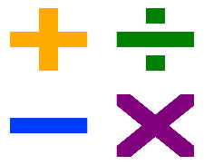
Introduction to 10 Week Functional Skills Maths course
Free to adults who have lived in the UK or EU for 3 years or more and who do not have a GCSE grade C or equivalent in maths

This course will improve your understanding, skills and confidence with maths and will prepare you to take the next step onto a Functional Skills qualification course at college.

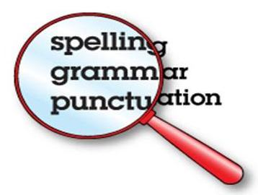
Introduction to 10 Week Functional Skills English course
Free to adults who have lived in the UK or EU for 3 years or more and who do not have a GCSE grade C or equivalent in English.
Please note this is not an ESOL course.

This course will improve your understanding, skills and confidence with English and will prepare you to take the next step onto a Functional Skills qualification course at college.

6 week Supporting your Child with Reading and Writing in the Early Years to KS1
Free to adults who have lived in the UK or EU for 3 years or more and who do not have a GCSE grade C or equivalent in English

You will find out how to support your child with reading and writing using phonics, reading strategies and how to support your child’s developing handwriting skills.
This course will improve your understanding, skills and confidence when supporting your child.

6 week Supporting your Child with Maths
skills at Primary School yr 1- yr 4

Free to adults who have lived in the UK or EU for 3 years or more and
who do not have a GCSE grade C or equivalent in maths

You will find out how to support your child with number skills and vocabulary.
This course will improve your understanding, skills and confidence when supporting your child.

6 Week Course
Creating Confident Children

Free to adults who have lived in the UK or EU for 3 years or more.
This is a course for parents and carers who want to find out how to support their child in the following areas:

- Building confidence when speaking and listening to others.
- Managing emotions when things feel overwhelming or unfair.
- Developing resilience when dealing with difficulties.
- Feeling positive, working with others and learning to problem solve

You will develop practical strategies for supporting your child and building up their confidence to deal with the world around them.

