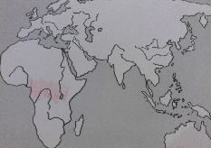
Cadbury Class
Newsletter: 28th February 2020

This Term
We are continuing our topic on WWF (World Wide Fund for Nature) which will culminate with our next open day on Friday 27th March to coincide with Earth Hour.
We’ve been studying animal habitats and understanding the importance of conservation to help save these wonderful creatures.
We have been creating a range of wonderful pieces of work to share with you at our exhibition and we look forward to seeing you on Friday 27th March from 2.30pm in the assembly hall!

Commando Joe.
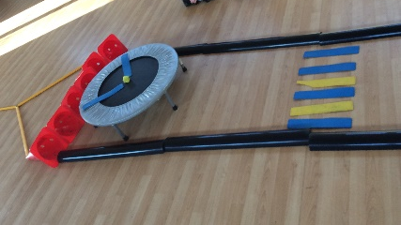
Each week we spend time together, working as a team collaborating and taking turns to create structures such as Big Ben. The children have been using fantastic communication skills and problem solving skills.

Some of our outstanding work last term!

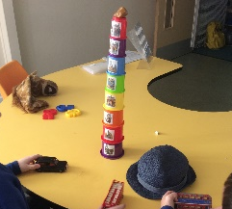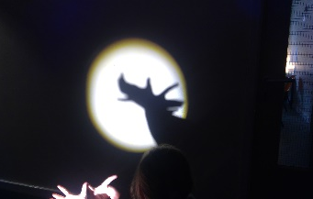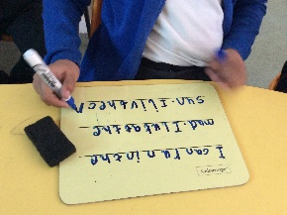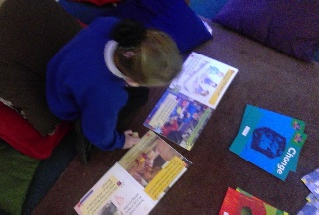

Autism Awareness Week is at the end of March – more information to follow!

Please continue to read with your children and remember you can also access Oxford Owl for wonderful books and resources – information on the class webpage on how to access this.

Should you have any questions, or need any support please do not hesitate to contact us and remember to keep visiting our Cadbury Class webpage at www.victoriaprimaryschool.org.uk which we aim to update each week!

Cadbury Class Team.

Diary Dates: Spring 2020

Date | Year Group | Time | Event
Friday 28th February | Year 2 | am | Trip to Derby Art Gallery
Tuesday 3rd March | Year 4 | All day | Trip to Wollaton Hall (The Romans)
Wednesday 4th March | Year 1 | 9.00 – 9.30 am | Year 1 Phonics Test –  Meeting for Parents
Thursday 5th March | All | day | World Book Day
Friday 6th March | Year 3 | day | Ancient Egypt day at Derby Museum
 | Year 5 | day | Art and Architecture visit to  St Peter’s Church
Monday 9th March | Mini Police | am | National Justice Museum Visit
Monday 9th to  Friday 13th March | ALL |  | STEM WEEK: Science, Technology, Engineering & Maths events- all classes
Thursday 12th March | All | day | Sports Relief Charity Day
Monday 16th March | Year 6 | 3.30 – 4.00 pm | SATs meeting for families
Thursday 19th and  Friday 20th March | All | p.m. | Mother’s Day Afternoon Tea
Wednesday 25th March | Year 5 | am | Visit to Cornerstone church Easter event
Wednesday 25th March | Year 5 | 3.15pm | Parent meeting for residential trip
Friday 27th March | Cadbury Class | 2.30pm | WWF Exhibition
Thursday 26th March | Year 3 | pm | Sports Festival (selected children only)
Wednesday 1st April | All | 2.00 – 4.30 pm | Parent – Teacher Meetings
Thursday 2nd April | All | 3.30 – 6.00 pm | Parent – Teacher Meetings
 | Years 3 & 4 | 2.00 – 3.00 pm | Big Class Assembly for families
Friday 3rd April | All | 3.15pm | School Closes for Easter Holiday
Monday 20th April | All | 8.45am | School re-opens

