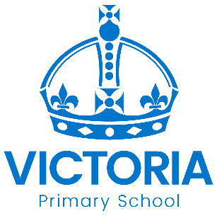

Cadbury Class
Newsletter: 28th October 2019

Last term, the children amazed us with incredible writing, super maths and a fantastic attitude. We are still focussing on following rules and making good choices but are excited and ready for another magnificent term with awesome children!

This Term

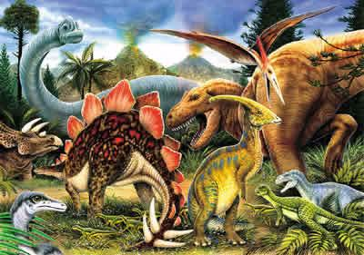
Topic
Our topic this term will be dinosaurs!
We will be learning about dinosaurs, digging for dinosaur remains, drawing, counting and creating our own dinosaurs.
We will hopefully incorporate a fun learning experience or trip relating to dinosaurs too – more details to follow.

Life Skills
This term, we will be using a range of cheeses for cooking and baking and we will also discuss how to create a balanced diet. We will also focus on road safety, personal hygiene and dressing appropriately for different seasons.

Homework
Your child’s class teacher may send home a homework booklet. You can work on this with your child, however, our expectations are for you to read daily with your child (information on paired reading on the class webpage), read our topic words, and practise key words for the term. Should you wish to have further homework, please let us know.

Open Day
We will have an open day on Thursday 21st November 2pm-3pm. Come and join us for fun activities with your child. We will also lay out activities that you can use at home and you will also have chance to see your children’s books.

Diary Dates: Autumn 2019

Date | Year Group | Time | Event
Wednesday 30th October | Year 4 | All Day | Ancient Greek Day (children are invited to dress up –optional)
Thursday 31st October | Year 6 | 3.00pm | Deadline for applying for a Year 7 place for September 2020
Tuesday 5th November | All | After School | Book Fair in the Sports Hall this week
Friday 8th November | Reception Boot | 08.45 to 10.00 am | Stay & Play session - Boot Class families
Monday 11th November | All |  | National Anti-bullying Week
Wednesday 13th November | Year 5 | Day | Science trip to National Space Centre
Friday 15th November | All | Day | Children in Need Charity Event  Non-uniform day
Friday 15th November | Reception Bell | 08.45 to 10.00 am | Stay & Play session - Bell Class families
Monday 18th November | All | Day | Pupil Individual Photos
Wednesday 20th November | Nursery & Reception | Day | A visitor with owls!
Thursday 21st November | Cadbury | 2.00pm | Open Afternoon for families of  Cadbury Class
Wednesday 27th November | All | 2.00 – 4.30 pm | Parent – Teacher Meetings
Thursday 28th November | All | 3.30 – 6.00 pm | Parent – Teacher Meetings
Wednesday 4th December | All | Day | School Closed for Staff Training
Thursday 5th December | Choir | 3.00 – 4.30 pm | Meadows Christmas Lights Switch On
Friday 6th December | All | lunchtime | School Christmas Meal
Tuesday 10th December | Nursery & Reception | 9.30am | Early Years Christmas Nativity Show
Thursday 12th December | Year 5 | 2.00pm | Space Expo for Year 5 Parents
Thursday 12th December | All | Day | NHS Flu Immunisations (nose spray)
Friday 13th December | All | pm | Christingle at St George’s Church
Tuesday 17th December | Years 1 & 2 | 9.30am  2.00pm | Christmas Show Performance
Tuesday 17th December | Year 1 | Day | Homework Projects Day
Wednesday 18th December | Years 3 - 6 | 9.15am | Family Christmas Sing-along
Wednesday 18th December | All | 3.15pm | School closes for Christmas Holidays

