Cadbury Class
Newsletter: April 16th 2018

Cake-tastic!
Thank you for supporting our cake sale which made £60.46
We bought equipment for enhancing active time, and to develop our gross motor skills, including a trampette, balance beams and resistance bands.
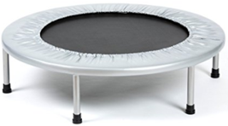

Summer Term
We will continue working on our superhero topic
Math: We will be learning about halving and doubling.
English: Using phonics in our reading and writing, forming our capital letters and taking part in why/ because conversations.
We will start an ‘all about me topic’ to include super foods linked to healthy eating and growing our own vegetables. This will be linked to how we grow and how to grow friendships (positive relationships) and how animals are born and grow.

Fabulous Free Reading Resource
Oxford Owl offer free books to read online and the best thing is that the children can listen to them at the same time! There are also free resources and support for parents.
Visit www.oxfordowl.co.uk and click on
Username: Cadbury
Password: choc

Please visit our class page
Our class page is up and running and you can find key information and see examples of excellent work. Please visit www.victoriaprimaryschool.org.uk then click on Cadbury Nurture in ‘class pages’

Thank you for your continued support.
Cadbury Nurture Staff

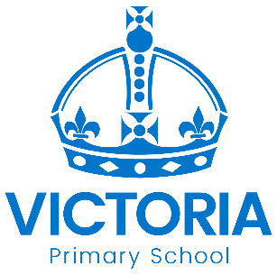

Diary Dates: April – May 2018

Date | Year Group | Time | Event
Monday 16th April | Y1 – Y6 | PM | Speak Out – Be Heard – Be Safe Assemblies with NSPCC
Wednesday 18th April | Year 4 & 5 | 9.00 – 9.45 am | Free Maths workshop for Y4 and Y5 with Miss Froggatt
Monday 23rd April | Years 5 & 6 | Day | Speak Out – Be Heard – Be Safe  Lessons with NSPCC
Monday 23rd April | All | 2.00pm – 3.00pm | Parents, Carers & Family Support  Free Coffee & Cake event
Monday 23rd April | All | 3.15 – 4.00 pm | Summer After School Clubs Start
Wednesday 25th April | Nursery, Reception, Year 1 | Day | White Post Farm animals  visiting school!
Thursday 26th April | Year 1  Nightingale & Seacole | Day | English Learning Visit to  Perlethorpe Outdoor Centre
Tuesday 1st May | Reception  Boot & Bell | Day | Extra Forest School Learning  with the RSPB
Thursday 3rd May | Year 1  Nightingale & Seacole | Day | Extra Forest School Learning  with the RSPB
Monday 7th May | All | Day | School Closed  National Bank Holiday
Tuesday 8th May | Darwin  Nursery | Day | Extra Forest School Learning  with the RSPB
Monday 14th May to  Thursday 17th May | Year 6  Bridgetower | AM | Year 6 National Tests (SATs)
Monday 21st May | 1, 3 & 5 | PM | Spanish Afternoon
Friday 25th May | All | 3.15 PM | School Closes for  May Half Term Holiday

