

Cadbury Class Newsletter
June 12th 2019

Transition
As we approach the end of another successful year, we are aware of many changes which can be difficult for some of our children. With this in mind, we will be focussing on transitional support through social stories, during our social groups and when considering our emotions and how to manage anxieties. Where necessary, children will also spend more time with their new class teacher to help build a positive relationship. We know this can be a worrying time for parents/carers too, so should you require any support, please do not hesitate to come in and speak to Miss Mousley, Mrs Bradford or your child’s class teacher.

Changes to Cadbury Class
A few new exciting changes for the next academic year will be a happening to Cadbury class. First, joining the Cadbury Team alongside Mrs Lee Bradford in September will be Miss Rachel Mousley who is incredibly excited to be teaching and supporting all children in Cadbury class. Secondly, we will be making changes to our curriculum and timetable to ensure all children can access learning at a more personalised level, this will include developing our sensory provisions and developing our speech and language interventions. We will also be changing our classrooms with one room specifically focussed on sensory needs and the other a more structured learning environment for writing and maths. We look forward to sharing our changes with you at our open day in September.

Cadbury Class Open day
We will have an open day with activities on Wednesday 26th June 2pm-3.15pm: make your way to reception to sign in. We will be having a mini-beast hunt and then, fingers crossed, releasing our butterflies. This will be Cadbury class’ final open day for this academic year and the children are also looking forward to sharing their progress with you so we hope you will be able to attend and we look forward to seeing you there!

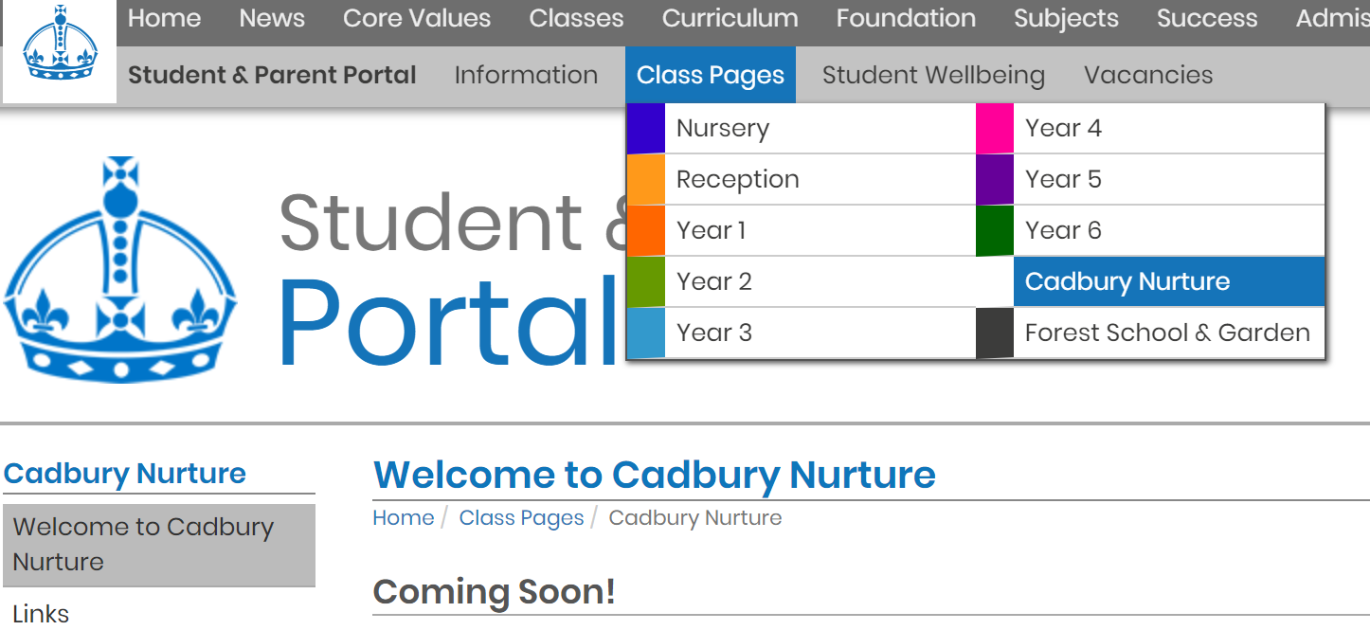
Cadbury Website
We will continue to update our class webpage with information, links and photos. Check it out at;
www.victoriaprimaryschool.org.uk and click on class pages.
There is also a dropbox with a wide range of resources linked to SEND, please see Rachel Mousley (SENCo) for the username and password.

Should you have any queries, please do not hesitate to speak to Miss Mousley or Mrs Bradford. Appointments can be made at the school office.

Cadbury Class Team

