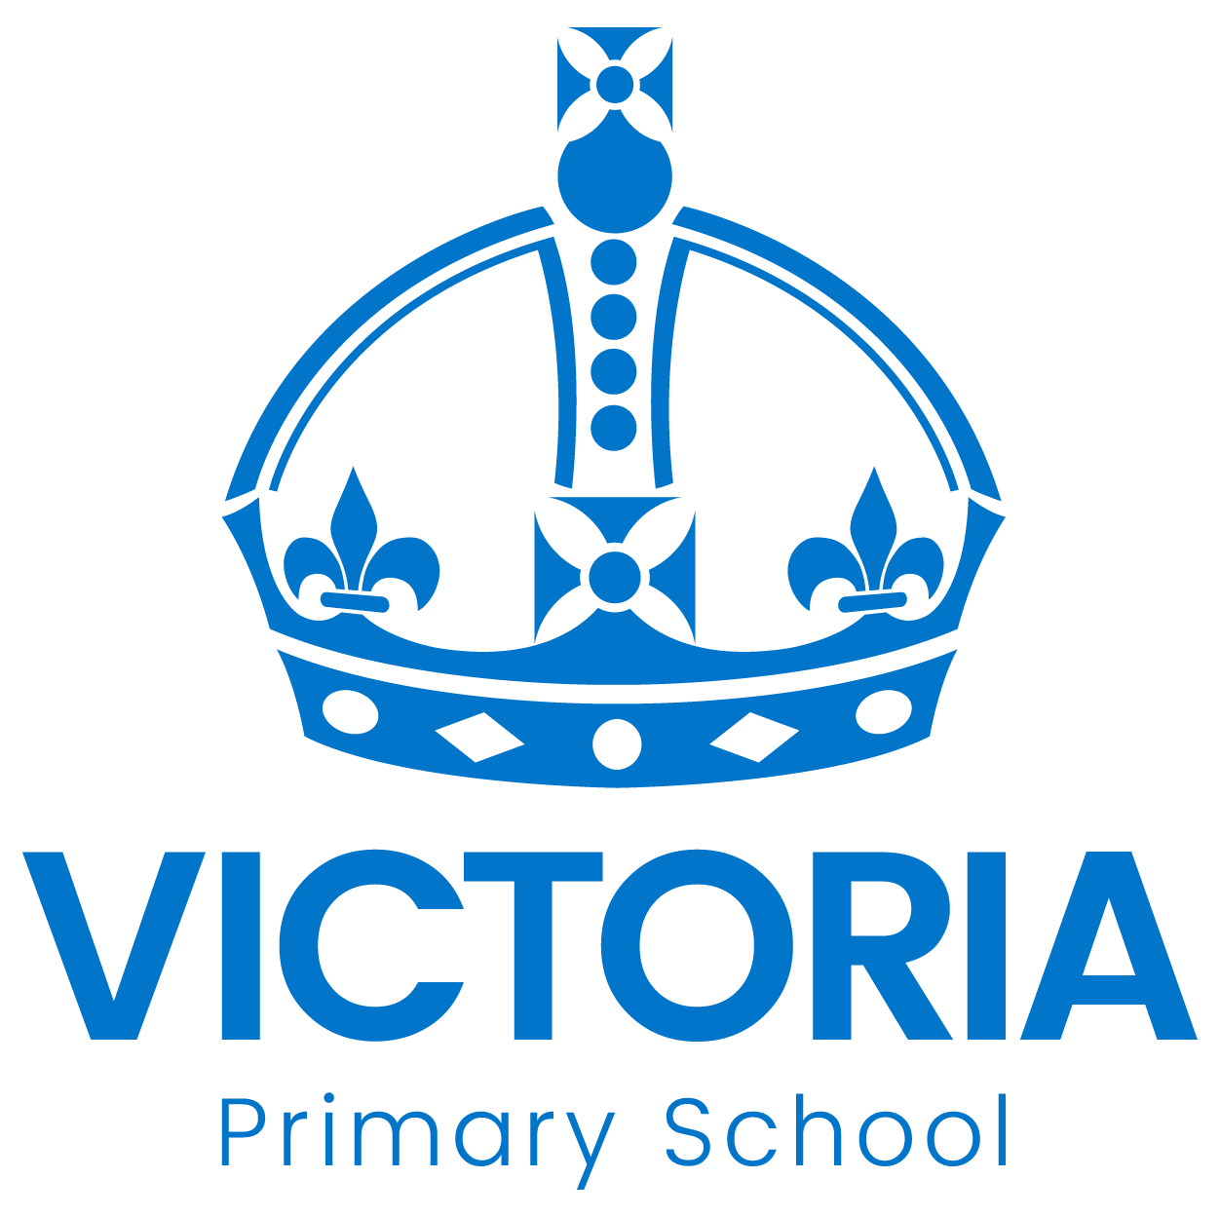

Cadbury Class Newsletter
February 27th 2018

A BIG thank you!
Thank you to those who came to work with your child in Cadbury class or visited us for our Open Event. There were lots of positive comments and we will be holding another one in the summer term.
Should you have any questions or require advice in the meantime, please feel free to make an appointment at the office for Miss Mousley or Mrs Bradford.

Spring Term
Our topic for this half term is Superheroes.
Maths: we will be learning about halving and doubling
English: using phonics in our reading and writing, forming our capital letters and taking part in why/ because conversations.
We will also be talking about new life connected to Easter.

There will also be an opportunity to buy some of our very own produce on the last day of term!

Fabulous Free Reading Resource
Oxford Owl offer free books to read online and the best thing is that the children can listen to them at the same time! There are also free resources and support for parents.
Visit www.oxfordowl.co.uk and click on 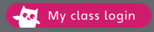
Username: Cadbury
Password: choc
Enjoy reading!

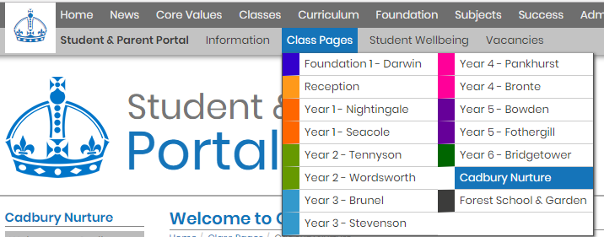
Please visit our class page
Our class page is up and running and you can find key information and see examples of excellent work. Please visit www.victoriaprimaryschool.org.uk then click on Cadbury Nurture in ‘class pages’

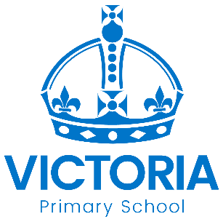

Diary Dates: March 2018

Date | Year Group | Time | Event
Thursday 1st March | Y1 – Y6 | Day | World Book Day  Non uniform – dress as a book character and come to celebrate getting into a good book.
Friday 2nd March | Reception  Y1, Y2, Y3 | AM | Free six week Parent Course  “Keeping up with the children in Maths”
Thursday 8th March | Year 3 | 9.00am | Year 3 Maths  Parents information session with Miss Cao
Thursday 8th March &  Friday 9th March | All | PM | Mothers’ Day Afternoon Tea
Monday 12th March | All | Day | STEM Day  (Science, Technology, Engineering & Maths fun for all classes)
Tuesday 13th March | Year 3 | Day | Egyptian History Visit to  New Walk Museum, Leicester
Wednesday 14th March | Year 5 | Day | Year 5 School Council go to represent our school at Nottingham Primary Parliament
Thursday 15th March | Year 6 | PM | English Visit to see ‘War Horse’ at  Nottingham Theatre Royal
Friday 16th March | All | PM | Sports Relief Events  Active fun to finish the week!
Wednesday 21st March | Year 5 | Day | Science Visit to  Think Tank Museum, Birmingham
Monday 26th March | Y3 & Y5 | PM | Arabic Afternoon
Tuesday 27th March &  Wednesday 28th March | All | PM | Parent – Teacher Meetings
Friday 30th March | All | 3.15pm | School Closes for the Easter Holiday
Monday 16th April | All | 8.55am | School reopens for the Summer Term

